ID | Age | Job | House | Credit | Class
1 | Old | False | True | Excellent | Yes
2 | Old | False | True | Good | Yes
3 | Middle | False | False | Fair | No
4 | Middle | True | True | Good | Yes
5 | Young | False | False | Fair | No
6 | Old | False | False | Fair | No
7 | Middle | False | True | Excellent | Yes
8 | Young | True | False | Good | Yes
9 | Young | True | True | Fair | Yes
10 | Middle | False | False | Good | No
ادامه می‏دهیم
ID | Age | Job | House | Credit | Class
1 | Old | False | True | Excellent | Yes
2 | Old | False | True | Good | Yes
3 | Middle | False | False | Fair | No
4 | Middle | True | True | Good | Yes
5 | Young | False | False | Fair | No
6 | Old | False | False | Fair | No
7 | Middle | False | True | Excellent | Yes
8 | Young | True | False | Good | Yes
9 | Young | True | True | Fair | Yes
10 | Middle | False | False | Good | No
ID | Age | Job | House | Credit | Class
1 | Old | False | True | Excellent | Yes
2 | Old | False | True | Good | Yes
3 | Middle | False | False | Fair | No
4 | Middle | True | True | Good | Yes
5 | Young | False | False | Fair | No
6 | Old | False | False | Fair | No
7 | Middle | False | True | Excellent | Yes
8 | Young | True | False | Good | Yes
9 | Young | True | True | Fair | Yes
10 | Middle | False | False | Good | No
ID | Age | Job | House | Credit | Class
1 | Old | False | True | Excellent | Yes
2 | Old | False | True | Good | Yes
3 | Middle | False | False | Fair | No
4 | Middle | True | True | Good | Yes
5 | Young | False | False | Fair | No
6 | Old | False | False | Fair | No
7 | Middle | False | True | Excellent | Yes
8 | Young | True | False | Good | Yes
9 | Young | True | True | Fair | Yes
10 | Middle | False | False | Good | No
ID | Age | Job | House | Credit | Class
1 | Old | False | True | Excellent | Yes
2 | Old | False | True | Good | Yes
3 | Middle | False | False | Fair | No
4 | Middle | True | True | Good | Yes
5 | Young | False | False | Fair | No
6 | Old | False | False | Fair | No
7 | Middle | False | True | Excellent | Yes
8 | Young | True | False | Good | Yes
9 | Young | True | True | Fair | Yes
10 | Middle | False | False | Good | No
ID | Age | Job | House | Credit | Class
1 | Old | False | True | Excellent | Yes
2 | Old | False | True | Good | Yes
3 | Middle | False | False | Fair | No
4 | Middle | True | True | Good | Yes
5 | Young | False | False | Fair | No
6 | Old | False | False | Fair | No
7 | Middle | False | True | Excellent | Yes
8 | Young | True | False | Good | Yes
9 | Young | True | True | Fair | Yes
10 | Middle | False | False | Good | No
ID | Age | Job | House | Credit | Class
1 | Old | False | True | Excellent | Yes
2 | Old | False | True | Good | Yes
3 | Middle | False | False | Fair | No
4 | Middle | True | True | Good | Yes
5 | Young | False | False | Fair | No
6 | Old | False | False | Fair | No
7 | Middle | False | True | Excellent | Yes
8 | Young | True | False | Good | Yes
9 | Young | True | True | Fair | Yes
10 | Middle | False | False | Good | No
ID | Age | Job | House | Credit | Class
1 | Old | False | True | Excellent | Yes
2 | Old | False | True | Good | Yes
3 | Middle | False | False | Fair | No
4 | Middle | True | True | Good | Yes
5 | Young | False | False | Fair | No
6 | Old | False | False | Fair | No
7 | Middle | False | True | Excellent | Yes
8 | Young | True | False | Good | Yes
9 | Young | True | True | Fair | Yes
10 | Middle | False | False | Good | No
ID | Age | Job | House | Credit | Class
1 | Old | False | True | Excellent | Yes
2 | Old | False | True | Good | Yes
3 | Middle | False | False | Fair | No
4 | Middle | True | True | Good | Yes
5 | Young | False | False | Fair | No
6 | Old | False | False | Fair | No
7 | Middle | False | True | Excellent | Yes
8 | Young | True | False | Good | Yes
9 | Young | True | True | Fair | Yes
10 | Middle | False | False | Good | No
ازآنجایی‌که کوچک‌ترین مقدار است بنابراين ابتدا بر اساس ويژگی House درخت ايجاد می‏گردد.
ID | Age | Job | House | Credit | Class
1 | Old | False | True | Excellent | Yes
2 | Old | False | True | Good | Yes
4 | Middle | True | True | Good | Yes
7 | Middle | False | True | Excellent | Yes
9 | Young | True | True | Fair | Yes

ID | Age | Job | House | Credit | Class
3 | Middle | False | False | Fair | No
5 | Young | False | False | Fair | No
6 | Old | False | False | Fair | No
8 | Young | True | False | Good | Yes
10 | Middle | False | False | Good | No
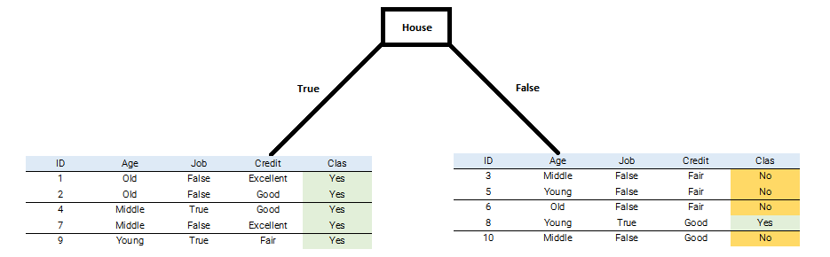
شاخۀ سمت چپ:
ID | Age | Job | Credit | Class
1 | Old | False | Excellent | Yes
2 | Old | False | Good | Yes
4 | Middle | True | Good | Yes
7 | Middle | False | Excellent | Yes
9 | Young | True | Fair | Yes
ادامه نمی‏دهیم
با توجه به این‌که است بنابراین شاخۀ سمت چپ ادامه پیدا نکرده و به برگ خواهیم رسید.
شاخۀ سمت راست:
ID | Age | Job | Credit | Class
3 | Middle | False | Fair | No
5 | Young | False | Fair | No
6 | Old | False | Fair | No
8 | Young | True | Good | Yes
10 | Middle | False | Good | No
ادامه می‏دهیم
ID | Age | Job | Credit | Class
3 | Middle | False | Fair | No
5 | Young | False | Fair | No
6 | Old | False | Fair | No
8 | Young | True | Good | Yes
10 | Middle | False | Good | No
ID | Age | Job | Credit | Class
3 | Middle | False | Fair | No
5 | Young | False | Fair | No
6 | Old | False | Fair | No
8 | Young | True | Good | Yes
10 | Middle | False | Good | No
ID | Age | Job | Credit | Class
3 | Middle | False | Fair | No
5 | Young | False | Fair | No
6 | Old | False | Fair | No
8 | Young | True | Good | Yes
10 | Middle | False | Good | No

ID | Age | Job | Credit | Class
3 | Middle | False | Fair | No
5 | Young | False | Fair | No
6 | Old | False | Fair | No
8 | Young | True | Good | Yes
10 | Middle | False | Good | No
ID | Age | Job | Credit | Class
3 | Middle | False | Fair | No
5 | Young | False | Fair | No
6 | Old | False | Fair | No
8 | Young | True | Good | Yes
10 | Middle | False | Good | No
ازآنجایی‌که کوچک‌ترین مقدار است بنابراين بر اساس ويژگی Job رشد درخت ادامه می‏یابد.
ID | Age | Job | Credit | Class
3 | Middle | False | Fair | No
5 | Young | False | Fair | No
6 | Old | False | Fair | No
10 | Middle | False | Good | No

ID | Age | Job | Credit | Class
8 | Young | True | Good | Yes
در اینجا با توجه به اینکه به‏واسطۀ تقسیم بر اساس ویژگی Job دو جدول ایجاد می‌گردد که یکی کاملاً متعلق به کلاس NO و دیگری کاملاً متعلق به کلاس Yes است، نیازی به ادامۀ محاسبات نیست؛ بنابراین ساختار نهایی درخت تصمیم به شکل زیر خواهد بود.
